**1.Encode the categorical variables to numeric values using IF condition.**

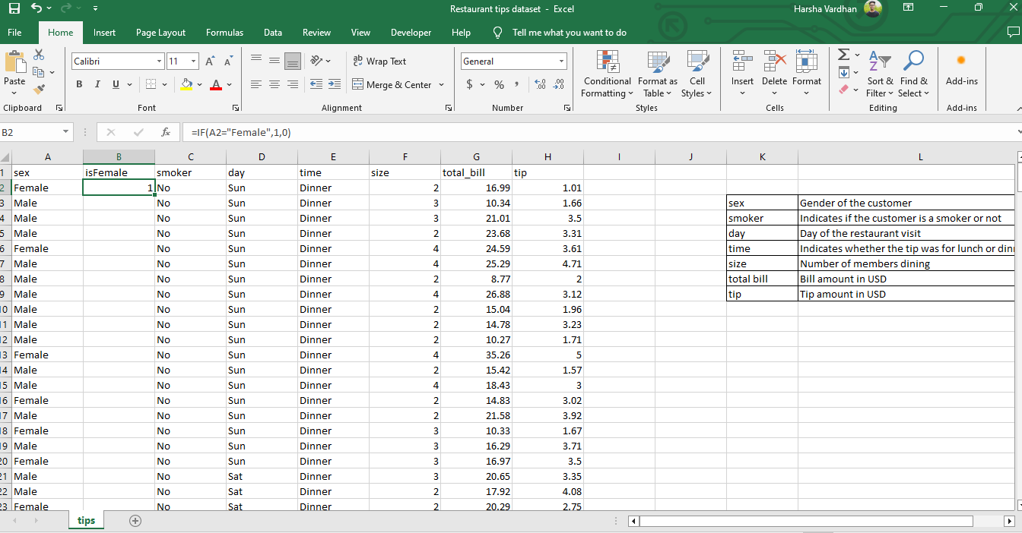

Use IF Condition as =**IF(A2=”Female”,1,0)**

Complete this step for all the headers until time header

After completing excel sheet will look as the below Screenshot

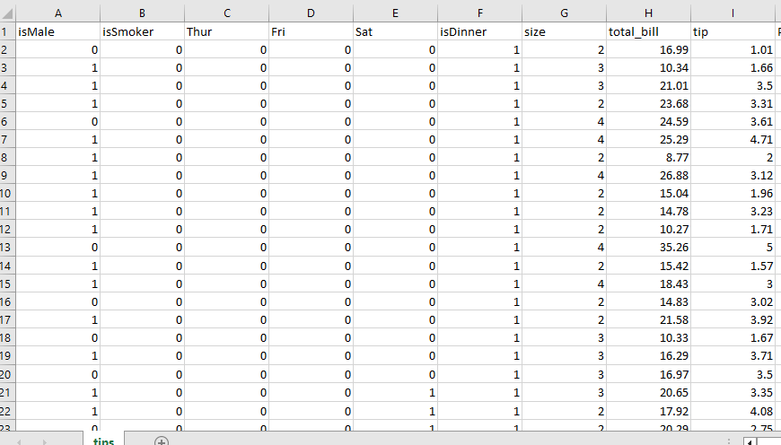

**2.Build an appropriate model**

To do it click on Data -> Data Analysis and then click on Regression

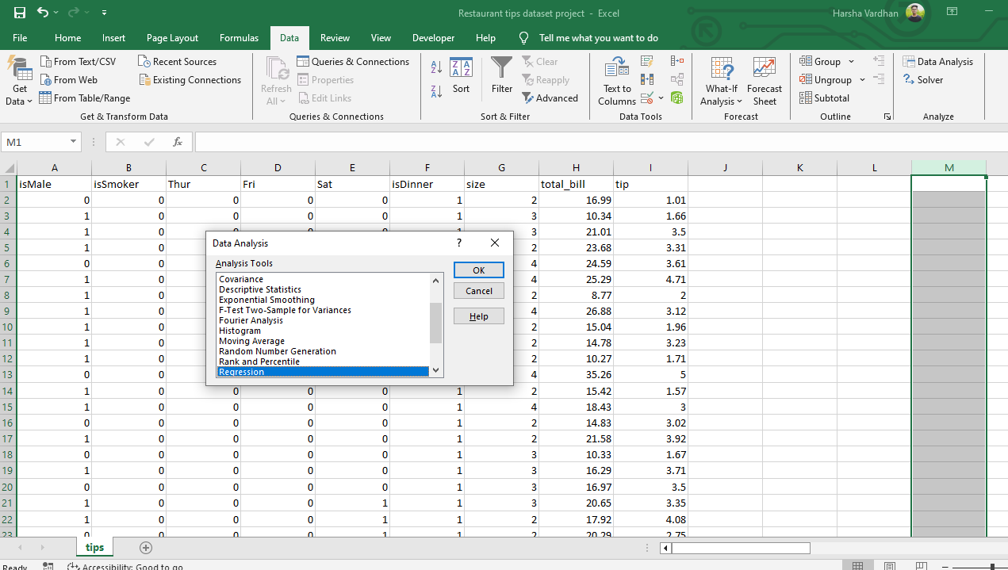

Select input and output Range as shown below

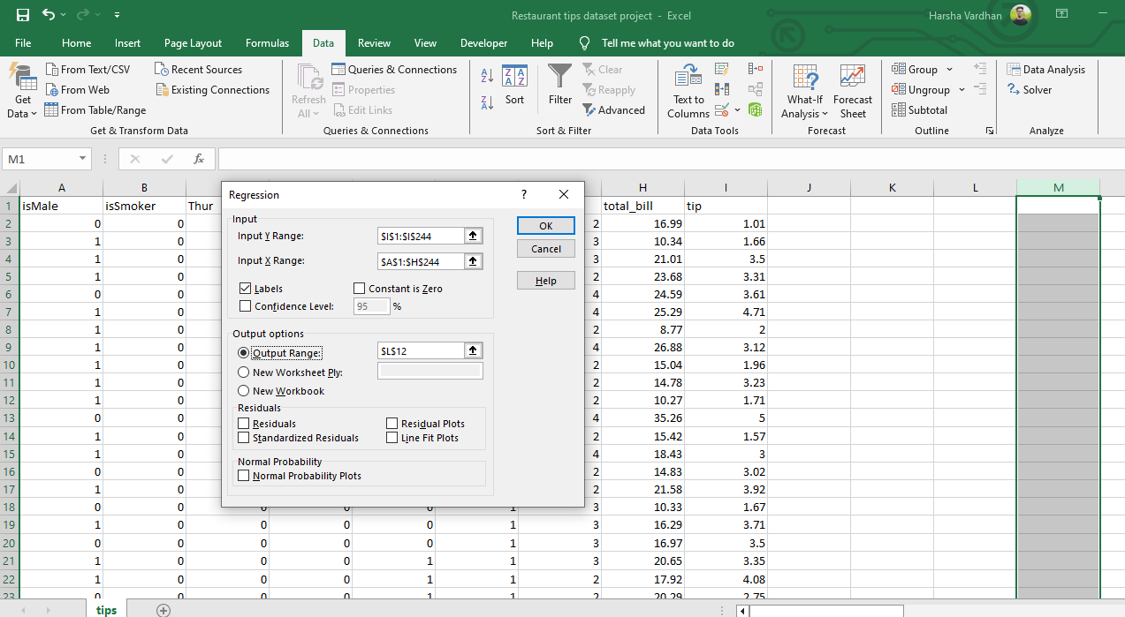

You will get Summary output as follows

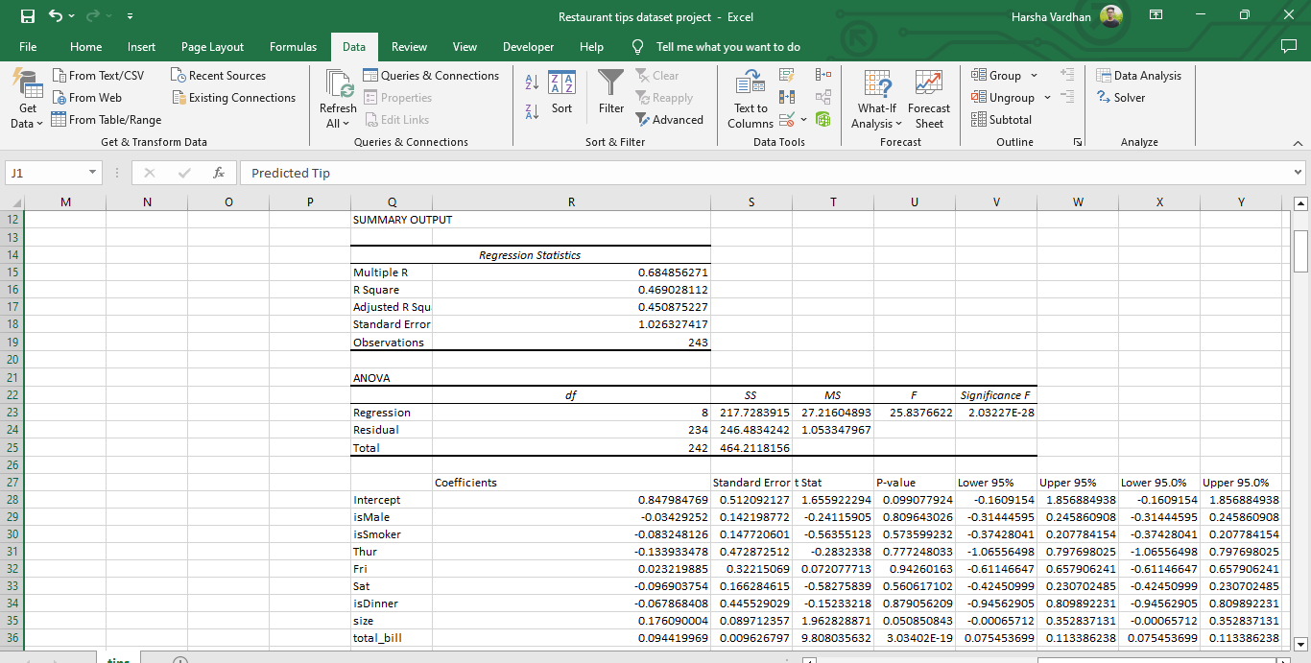

**3.Calculate Predicted and Actual tip**

To create predicted tip select all the conflicts and use the below formula to calculate Predicted

**Formula is =A2*$O$2+B2*$O$3+C2*$O$4+D2*$O$5+E2*$O$6+F2*$O$7+G2*$O$8+H2*$O$9+$O$1**

Output will be as below screenshot

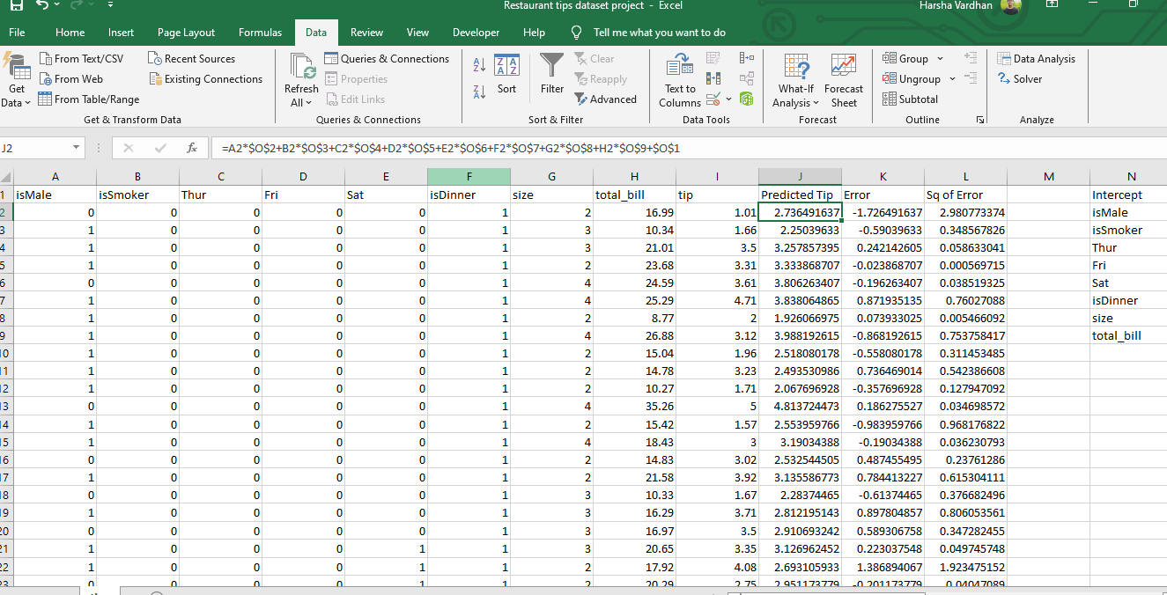

Then Calculate Actual tip with formula as

**Actual tip = Predicted tip – Tip** and the output is as shown below

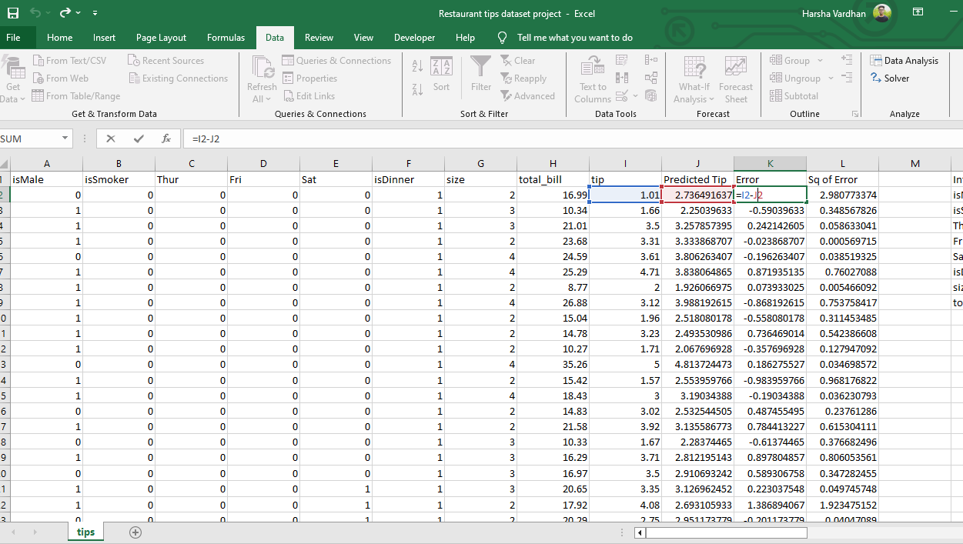

Then Calculate Square root of error with formula as **Error^2**

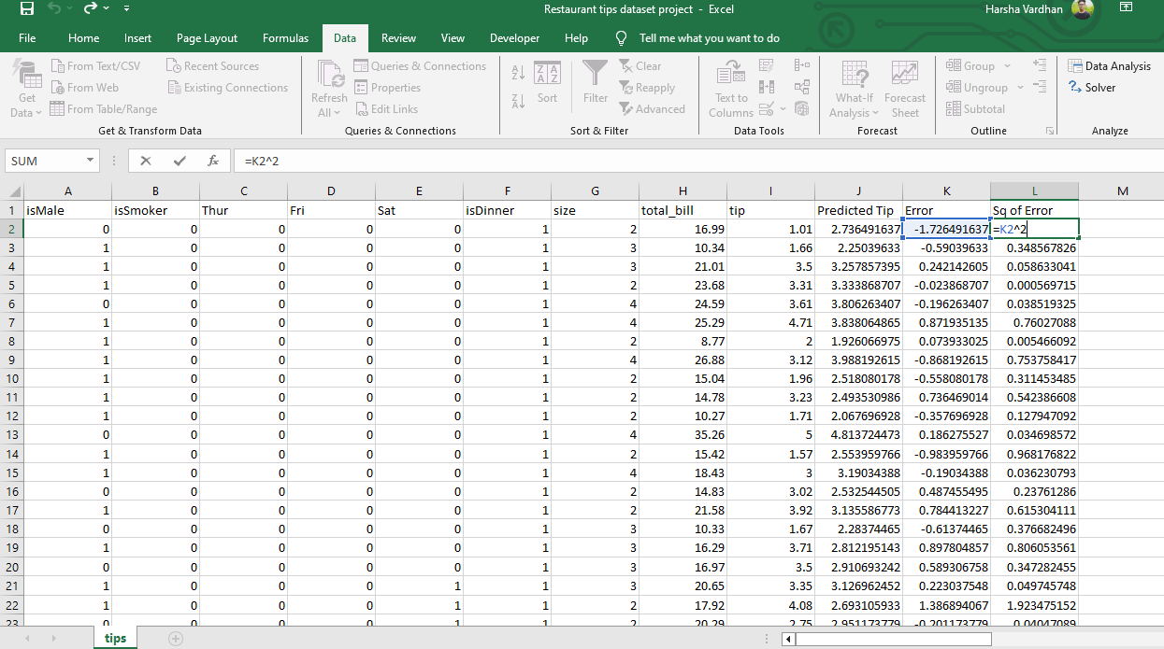

**4. Calculate RMSE (Root Mean Square Root) :**

First calculate Mean Square root by taking the average of Sq of Error in L coloums

Formula as **MSE=AVERAGE(L2:L244)**

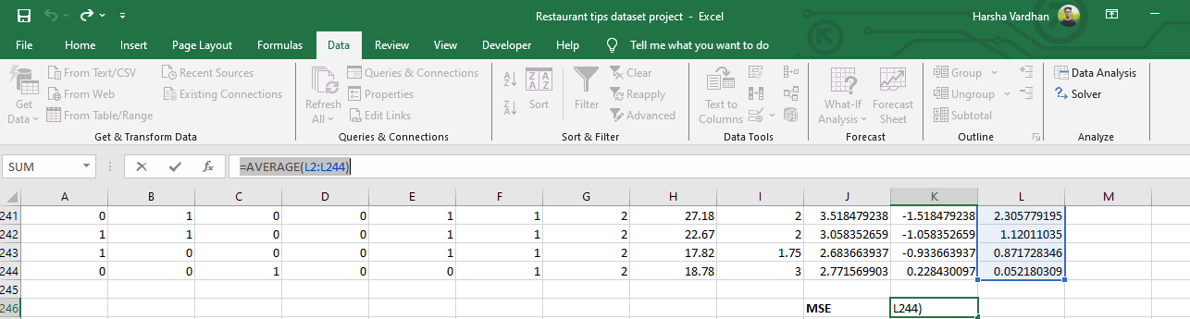

Now Calculate RMSE which is Square root of MSE

**RMSE = SQRT(K246)**

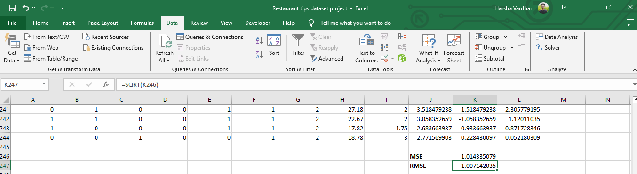

**RMSE is Calculated**